AHU Anomaly - Analysis Report

The AHU anomaly detection function **detects hard and soft faults related to air handling units (AHUs).** This function helps identify potential causes for anomalous AHU operations which may cause energy use inefficiencies. The visuals are intended to aid understanding of the detected faults. These depict supply air temperature, and the coolest/warmest/average return air temperatures as a function of outdoor air temperature, and damper and valve actuator positions as a function of outdoor air temperature. Additionally, a number of diagrams are generated which depict damper and valve actuator positions and temperature readings at characteristic AHU operational periods. More information is available at the respective sections.

# Visuals - Split-range controller

A set of two charts are generated for each AHU dataset inputted. The first (top) plots supply air temperature, and the coolest/warmest/average return air temperatures as a function of outdoor air temperature. For reference, the "ideal" supply air temperature is depicted. The second (bottom) chart is a Split-range controller diagram, which plots the outdoor air damper position (OA), heating coil valve position (HC), cooling coil valve position (CC) and average fraction of active perimeter heaters (RAD) with respect to outdoor air temperature. The four underlaying color zones represent the four distinct operating mode: Heating (red zone), economizer (yellow zone), economizer with cooling (grey zone), and cooling (blue zone). As an example, the below Split-range controller diagram is representative of normal, healthy AHU operations. Some

key characteristics of normal, healthy AHU operation

include:

* Heating coil active ONLY in heating mode
* Cooling coil active ONLY in economizer with cooling and cooling mode
* Heating and cooling coils should not operate simutaneously
* Perimeter heating should be minimal in economizer mode. This can be achieved by increasing the supply air temperature setpoint in the heating season, while monitoring any occurence of overheating.

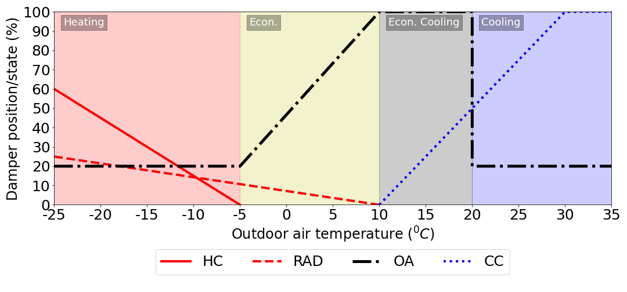

Suboptimal supply air temperatures can result excessive energy consumption from excessive perimeter heating use, economizing, or fan use. To guide supply air temperature setpoint adjustments, the typical "ideal" supply air temperature range is provided as a reference. If the supply air temperature is LOWER than this range in the heating season, excessive use of perimeter heating and economizing may result; only a few overheating rooms may trigger this behaviour. If this is the case, consider increasing the maximum terminal airflow setpoints in these overheating rooms.  
  
If the supply air temperature is HIGHER than this range in the cooling season, excessive fan power to deliver required necessary cooling may result; a few overcooling rooms may trigger this behaviour. If this is the case, consider decreasing the minimum terminal airflow setpoints in these overcooling rooms within reason. In both of these cases, ensure that the airflow and temperature sensors work as intended in these rooms.

## AHU: ahu1.csv



## AHU: ahu2.csv



# Visuals - AHU operating periods

A set of four to six visuals per AHU are generated which depict characteristic operating periods of the AHU and the average damper and valve positions and temperatures at those periods. The fraction of time of operation is the percentage of the total time of the AHU's operation which exhibit the displayed damper/valve positions and temperatures. Some

key characteristics of normal, healthy AHU operation

include:

* Heating coil active ONLY when the outdoor air temperature is below the upper setpoint for heating mode. (In the example split-range controller diagram provided, this is -5C.)
* Cooling coil active ONLY when the outdoor air temperature is above the upper setpoint for economizer mode. (In the example split-range controller diagram provided, this is 10C.)
* Heating and cooling coils should not operate simutaneously
* Perimeter heating should be minimal in economizer mode (i.e. when both the heating and cooling coils are inactive). This can be achieved by increasing the supply air temperature setpoint in the heating season, while monitoring any occurence of overheating.

## AHU: ahu1.csv

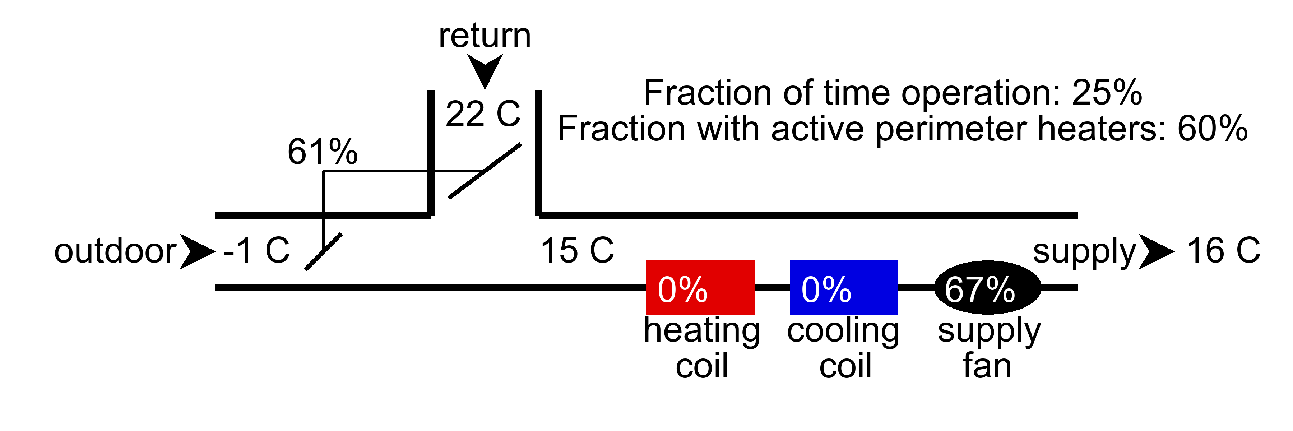

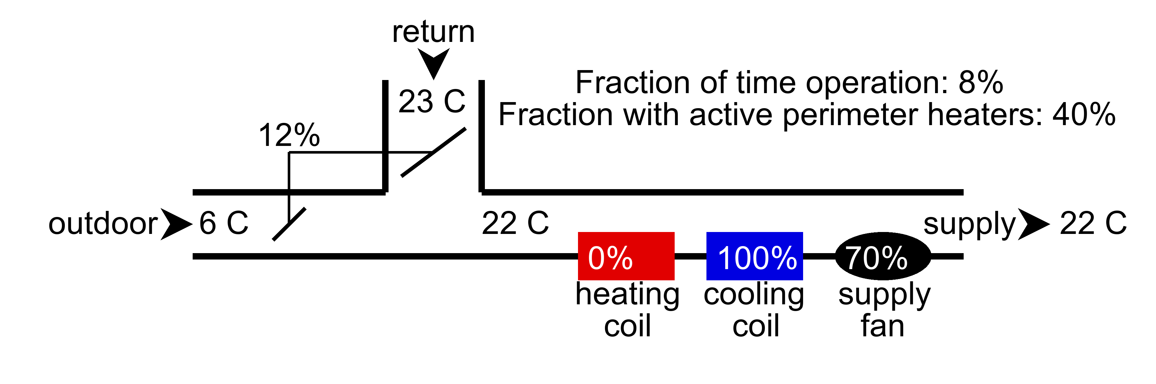

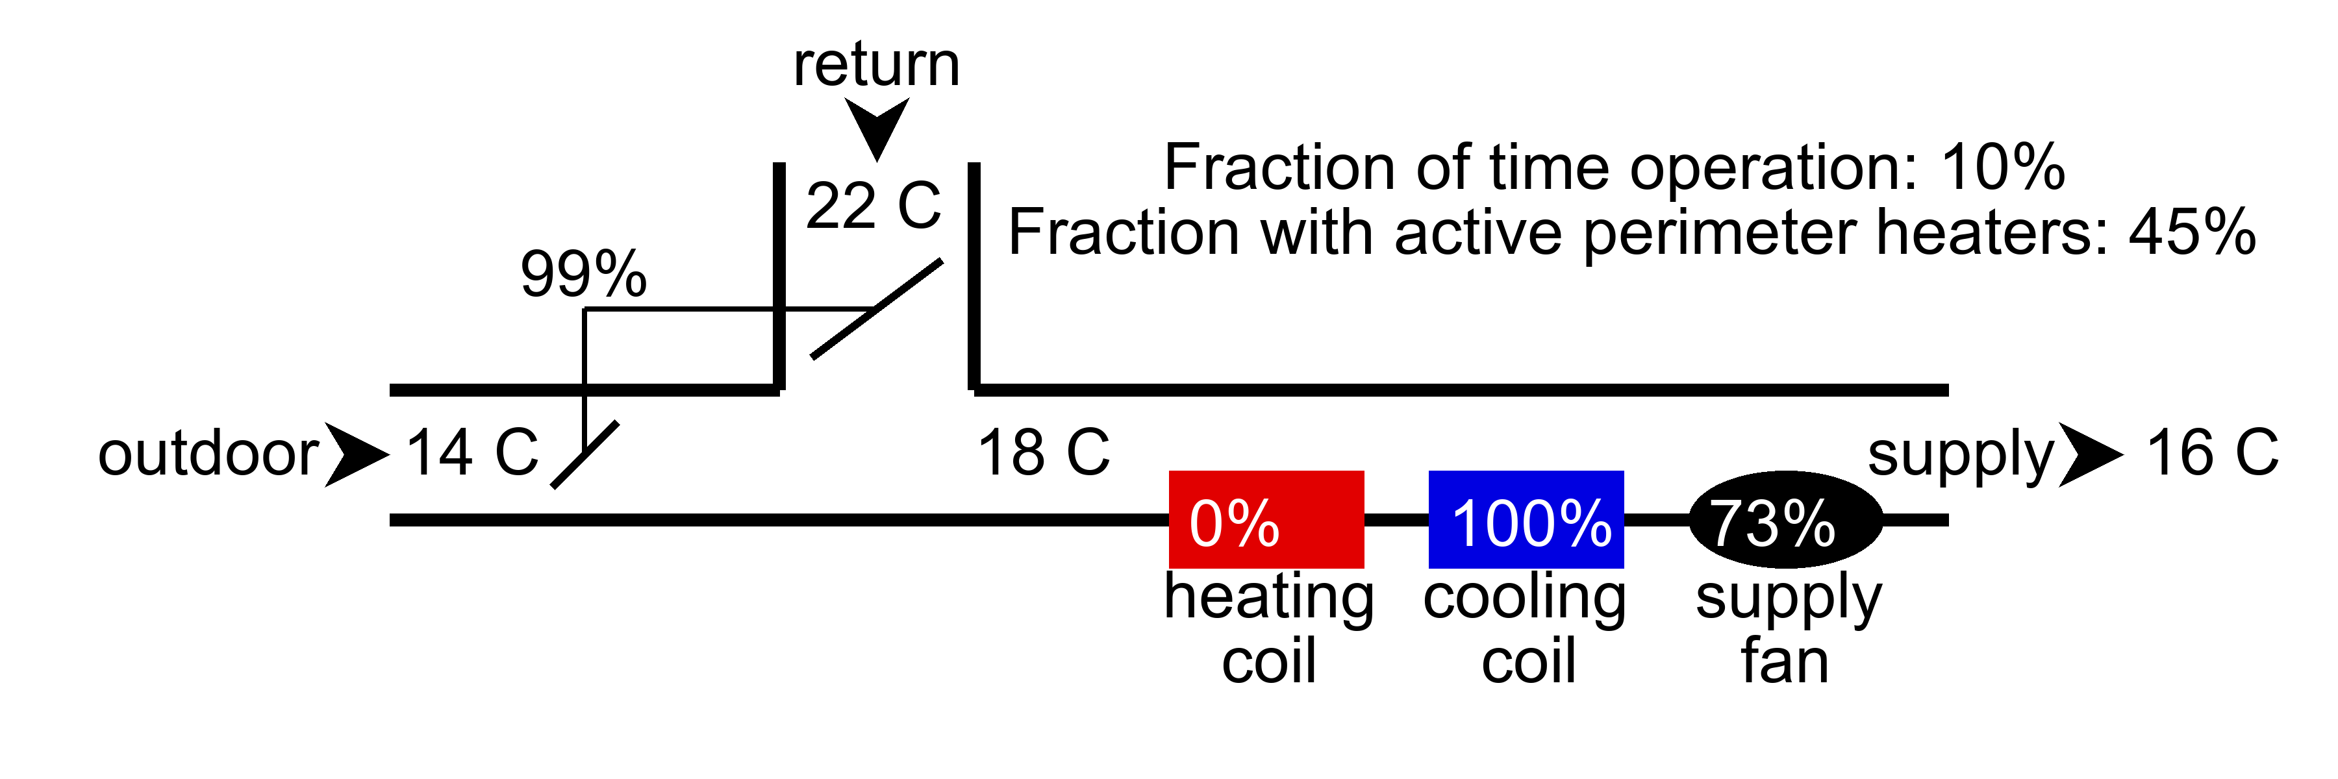

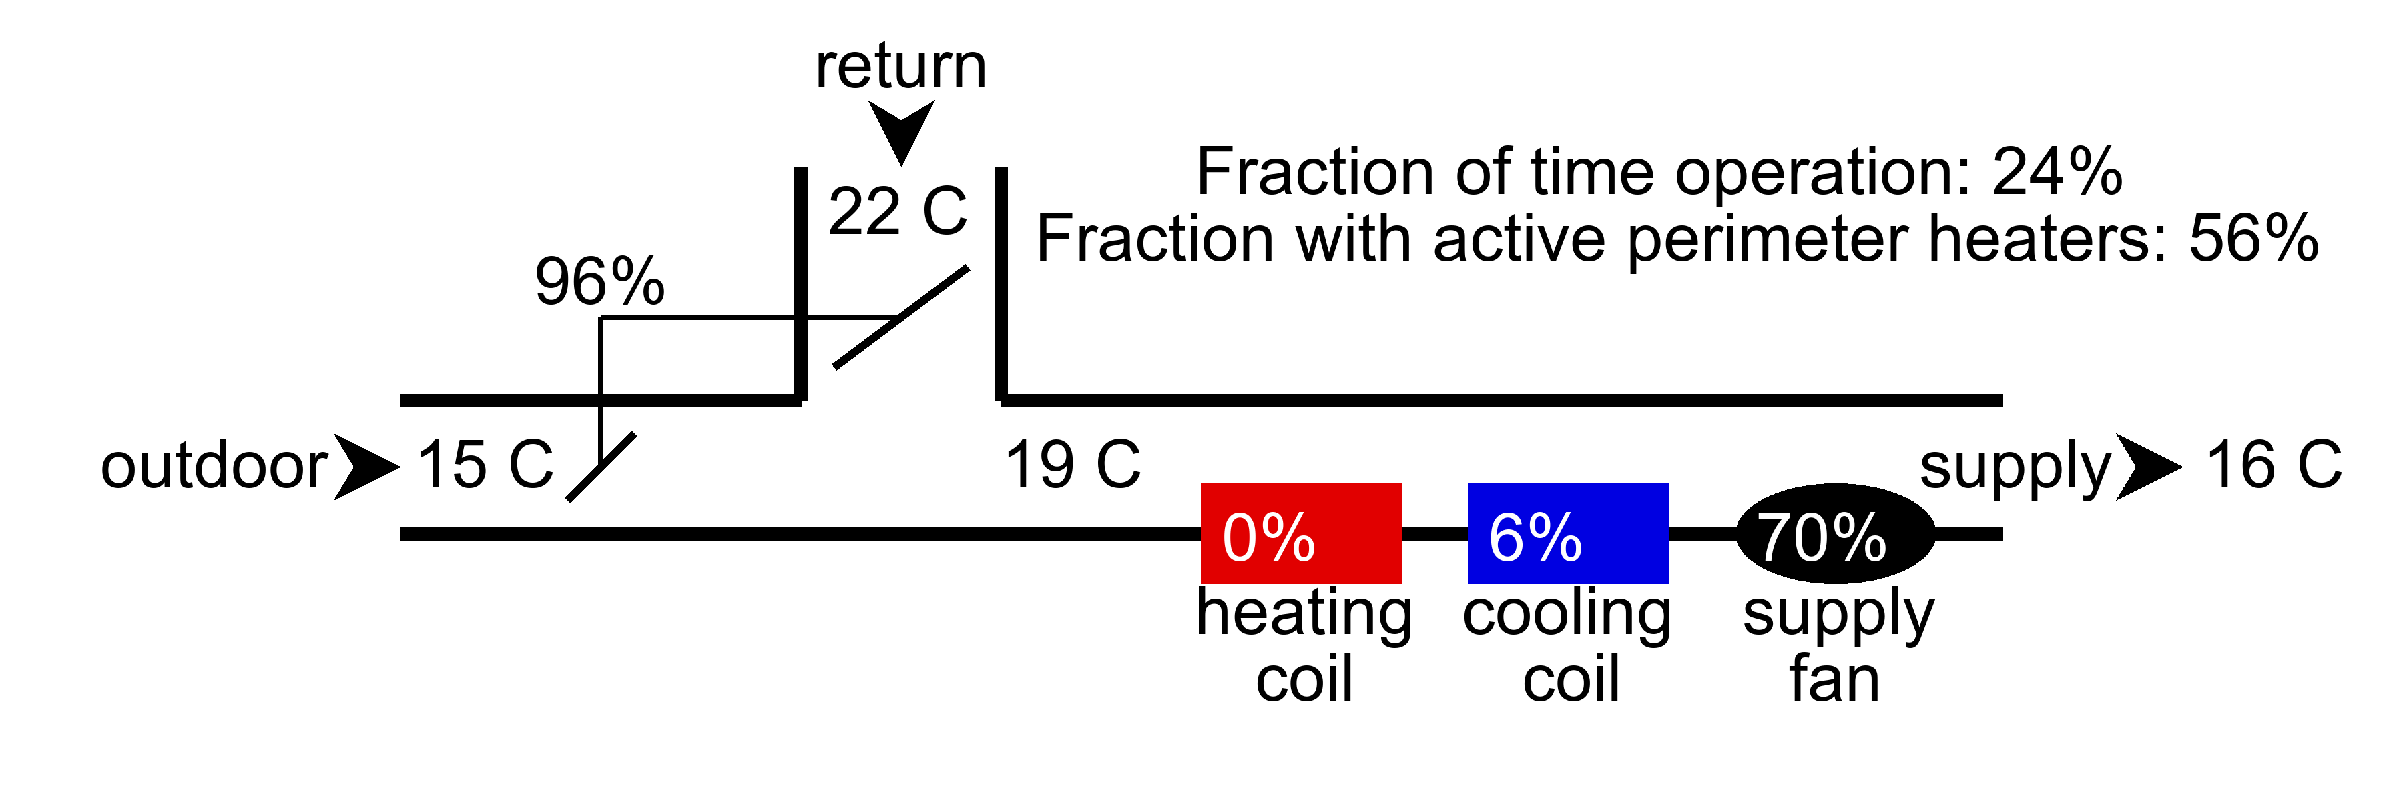

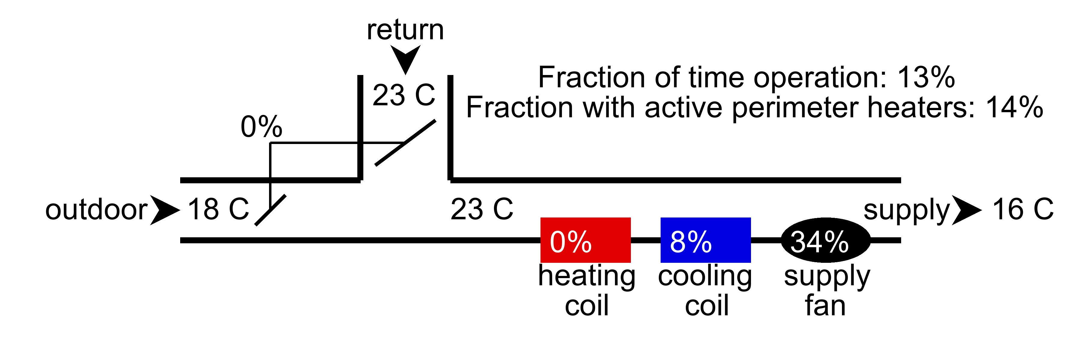

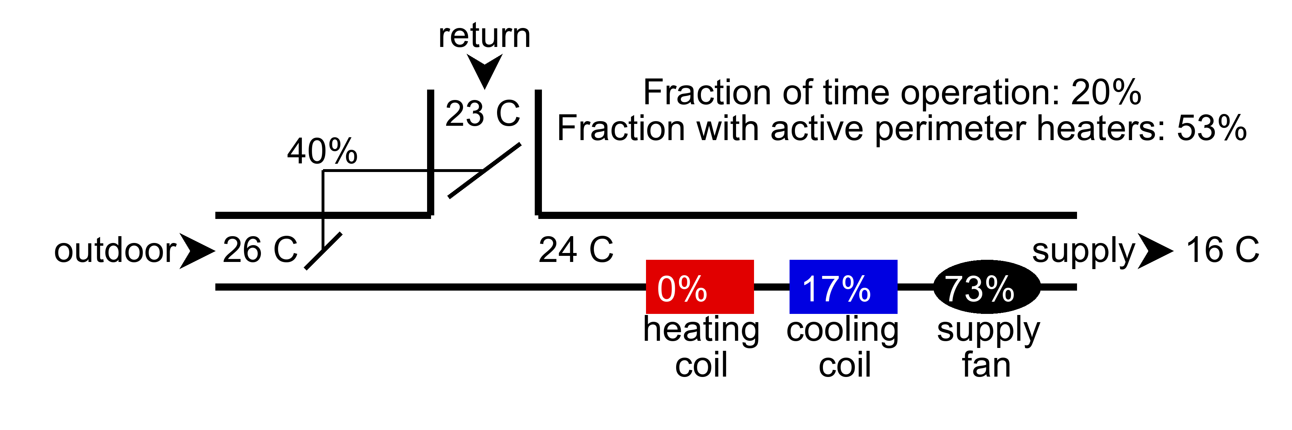

## AHU: ahu2.csv

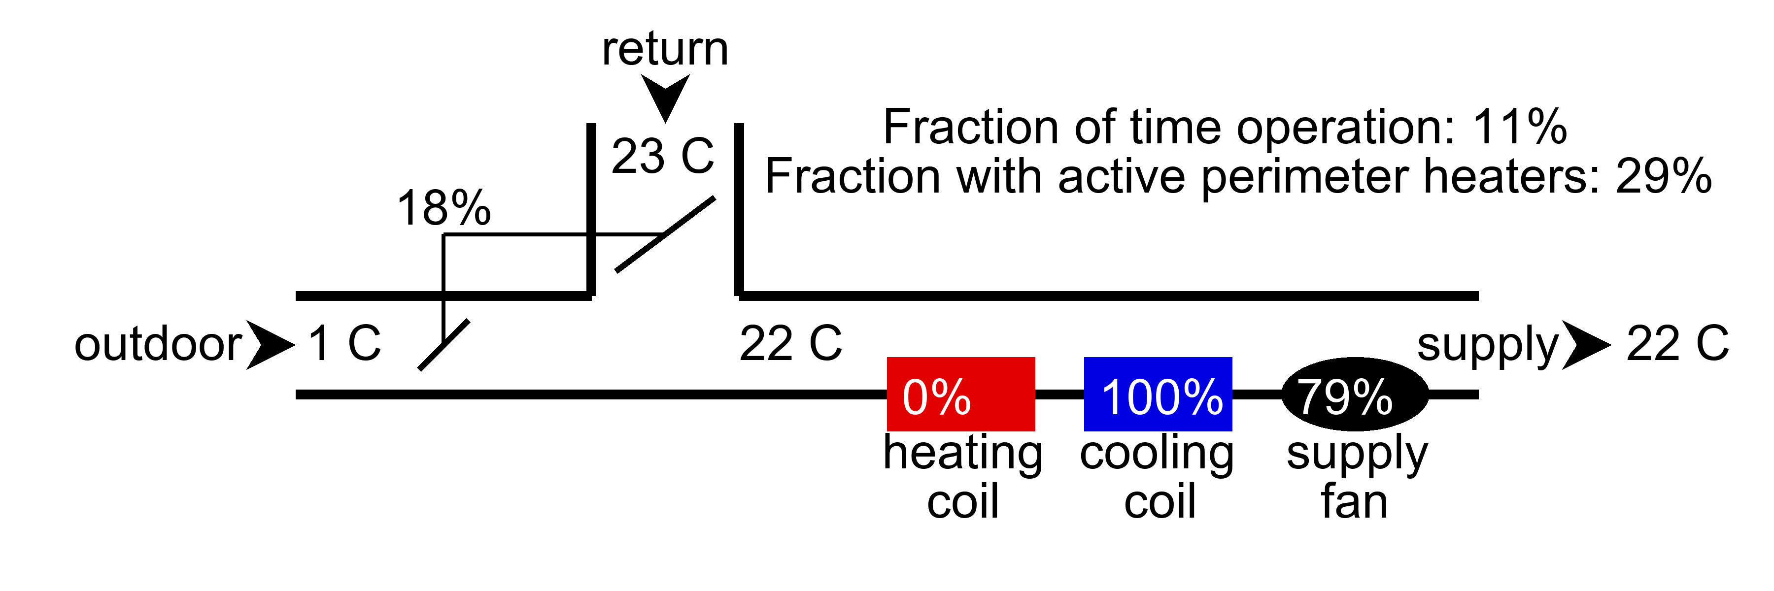

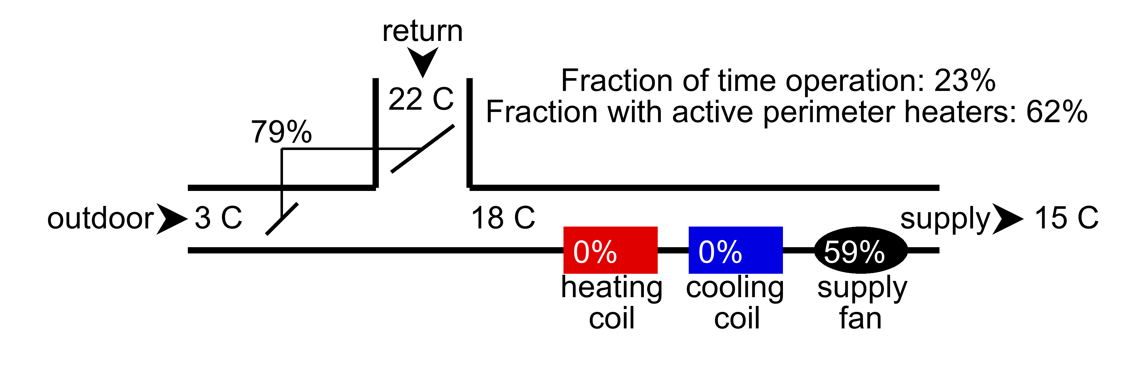

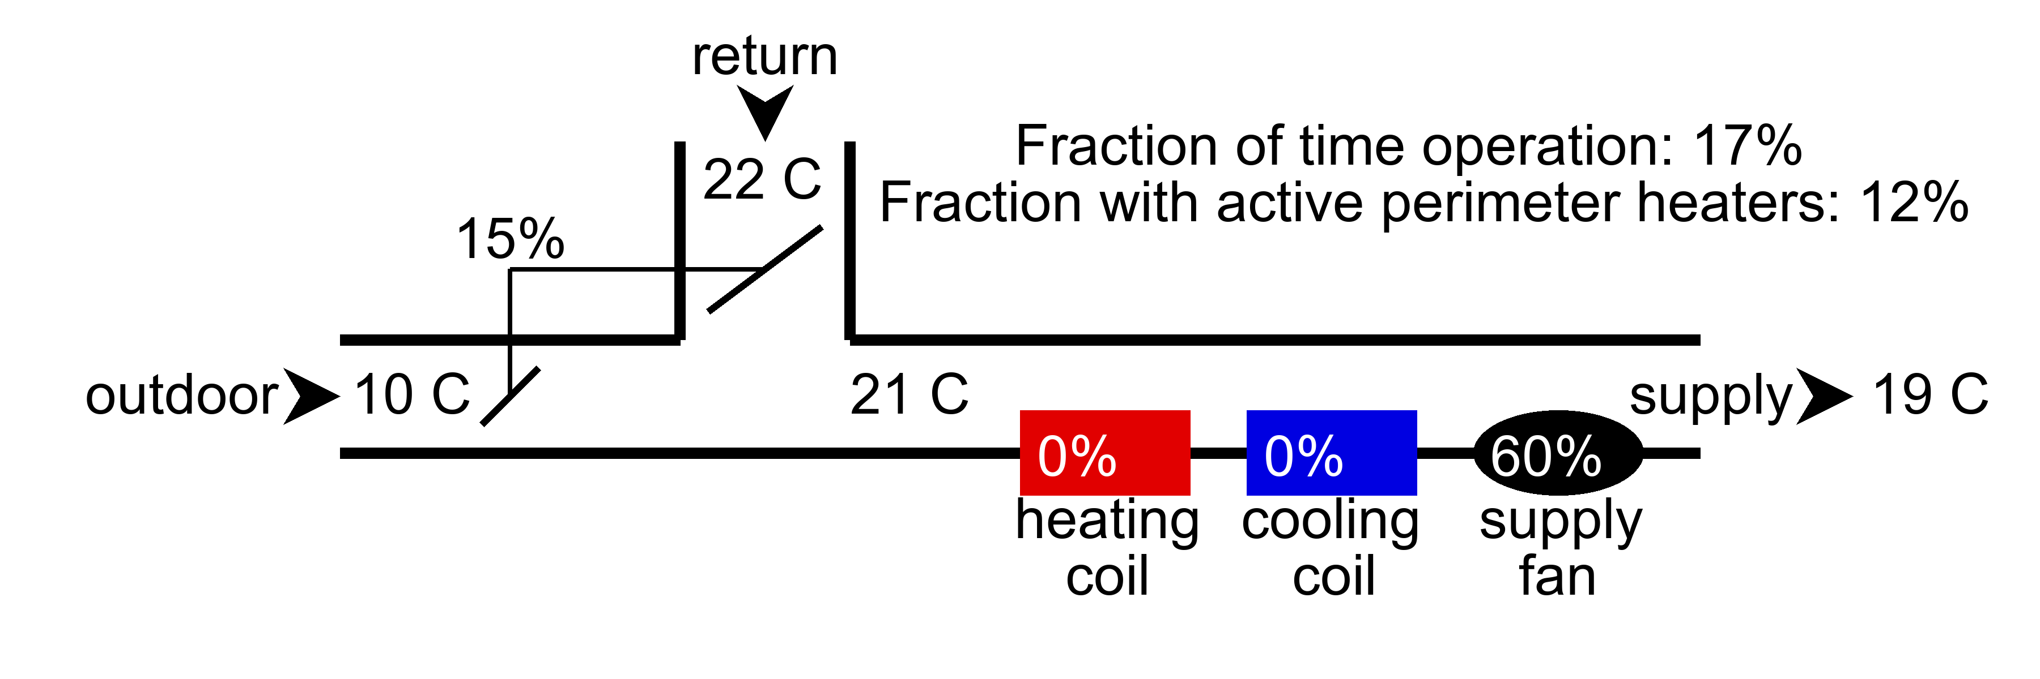

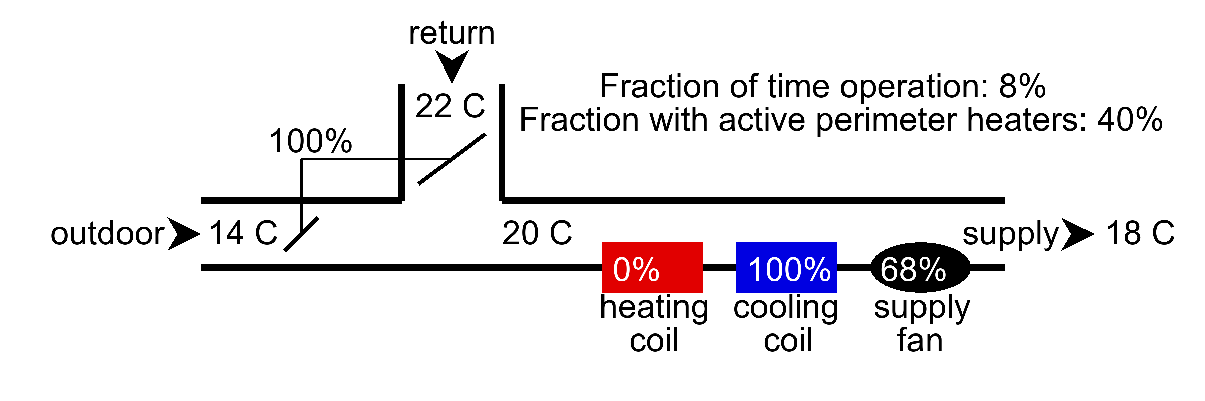

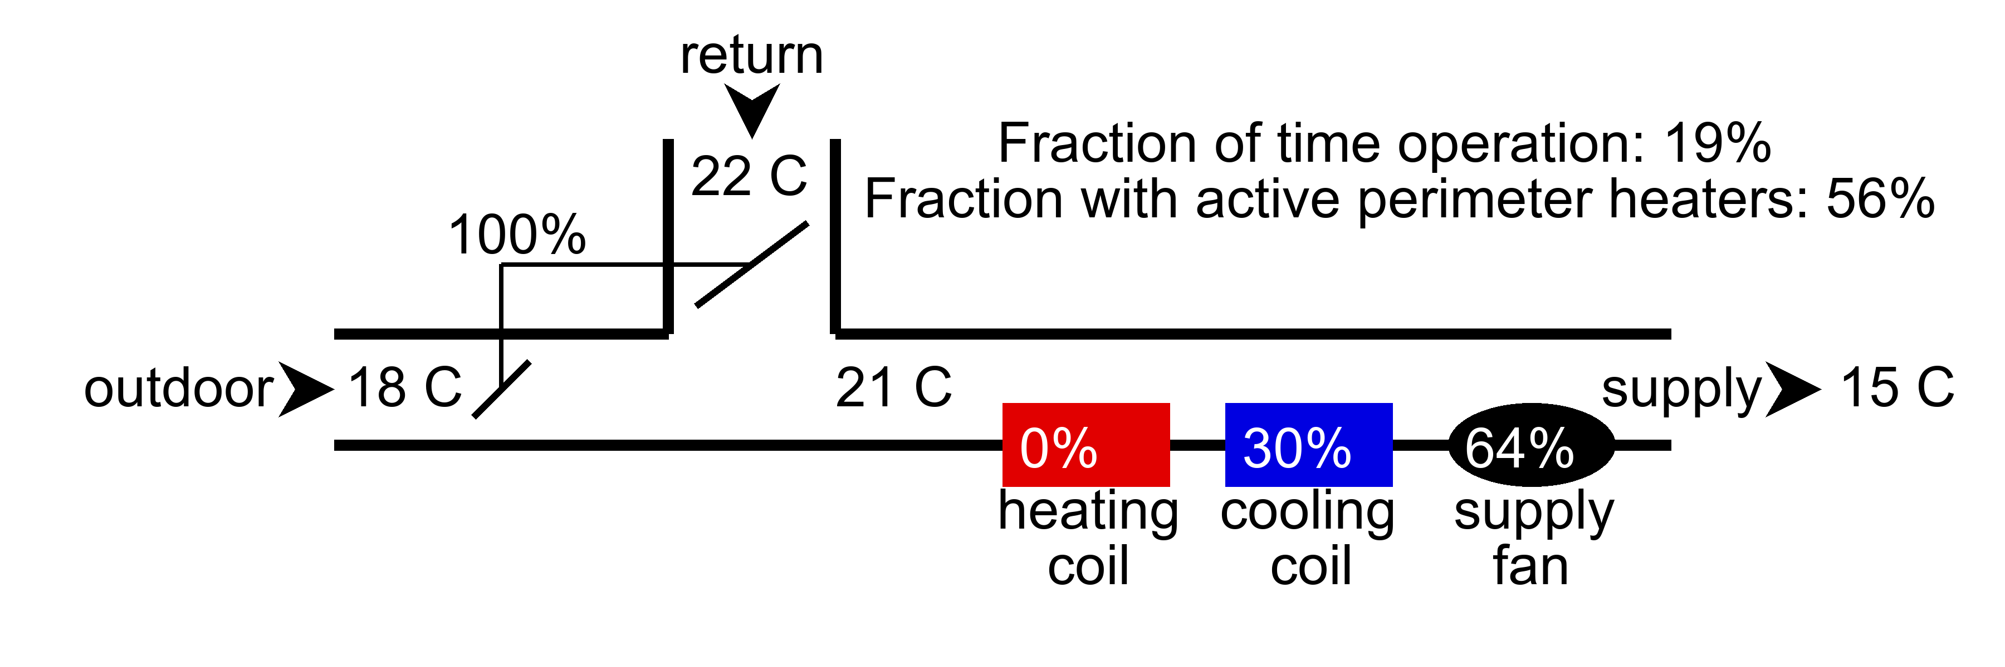

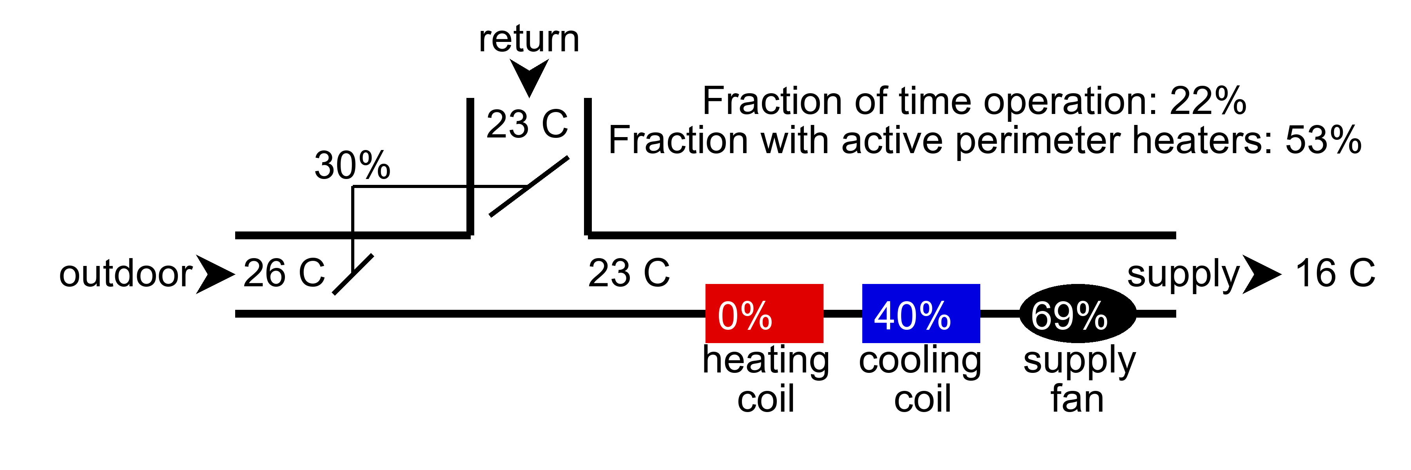

# Key performance indicators - AHU faults

The following table lists the hard and soft faults identified by the function. The AHU health index is also provided for each AHU which is 100% if no faults are detected and 0% if all six faults are detected. The following faults may be detected:

* Cooling coil stuck: This fault is generated if no or minimal use of the cooling coil was observed in the data. This may be symptomatic of a faulty sensor, a stuck valve, or a conflict in the operational logic.
* Heating coil stuck: This fault is generated if no or minimal use of the cooling coil was observed in the data. This may be symptomatic of a faulty sensor, a stuck valve, or a conflict in the operational logic.
* Check economizer logic: This fault is generated if excessive use of the perimeter heatings was observed in the AHU's economizer mode.
* Low/High outdoor air: This fault is generated if an inadequate or excessive amount of outdoor air was observed. This may be symptomatic of a stuck outdoor air damper or faulty damper sensor/actuator.
* Check mode of operation logic: This fault is generated if the weekly operational time (i.e. when the AHU fans are operational) exceeds 100 hours a week. This considered excessive operations. It is suggested to check the operational logic for any conflicts which may result in unintended operation of the AHUs
* Check supply air temperature reset logic: This fault is generated if there is excessive use of perimeter heating devices during the AHUs' economizer mode. This may be a result of select rooms overheating in the heatinmg season. If this is the case, consider increasing the maximum terminal airflow setpoints in these overheating rooms.

|  |  |  |  |  |  |  |  |
| --- | --- | --- | --- | --- | --- | --- | --- |
| AHU | AHU Health Index (%) | Cooling coil | Economizer | Heating Coil | Outdoor Air Damper | Schedule | Supply air temperature |
| ahu1.csv | 50% | Normal | Normal | Stuck | Normal | Check mode of operation logic | Check supply air temperature reset logic |
| ahu2.csv | 33% | Normal | Normal | Stuck | Low outdoor air | Check mode of operation logic | Check supply air temperature reset logic |